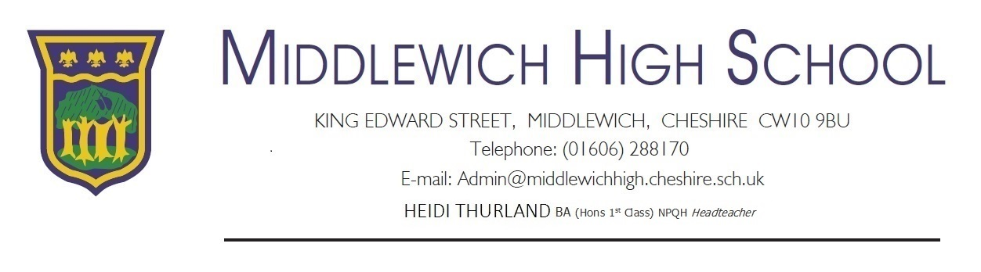
December 2019
Dear Parent/Carer,
I am writing to inform you of some important consultations regarding the school day, uniform and school site. I would also like to take this opportunity to share with you the outcomes of our recent Ofsted inspection and what this means for the school moving forward.
School Day Consultation:
In June this year we began a consultation on the structure of the school day for Sept 2019 and the times of the school day for Sept 2020. We are still in a consultation period regarding the school day for September 2020, this is an important reminder to families that if you wish to offer feedback you need to do so by Jan 15th 2020. We are proposing a slightly earlier start and finish time, this is mainly due to concerns over traffic safety as we dismiss students at the same time as local primaries. This is leading to significant congestion on local roads. We are proposing to begin school at 8.40am and to finish at 3.00pm.
School Uniform:
We have listened to students and the community regarding your concerns over the standard of uniform, notably the design of girl’s skirts. Therefore in September 2020 we are proposing a revised uniform and PE kit for students. We are currently looking at potential suppliers and designs to ensure cost effective, ethical, environmentally friendly, good quality uniform. We are proposing a new school blazer, school tie, a new pleated skirt and to move to white shirts rather than blue shirts. The school trousers will remain black. The new school tie will be provided to ALL students free in the first year. The PE kit will consist of a completely new design for all aspects, we will also be providing navy leggings as an option in response to student requests.
We are proposing a staggered approach to this in order to support families:
- Sept 2020 Yr11 students – uniform change is optional, new tie provided free of charge
- Sept 2020 New intake – All new Yr7 students have the new PE kit and school uniform; new tie provided free of charge
- Sept 2020 Yrs 8-10 – school uniform change is required however new PE kit is optional; new tie provided free of charge
- Sept 2021 – Yrs7-10 students in new uniform and PE kit , Yr11 in new uniform PE kit is optional
- Sept 2022 – All students in new PE kit & Uniform
We have decided that our school uniform and PE kit supplier will continue to be SWI/Banner who offer an online ordering service. We will write to families in due course regarding some opportunities for discounts in the summer term for new uniform orders. We are in the process of reviewing uniform designs and will be showcasing uniform & PE kit to students before we break for Christmas. We will publish visual designs on the website in due course.

School Site:
We are working closely with the Local Authority (LA) to improve the school site. Since my appointment I have completed a full site assessment with the LA who agree that the school requires significant investment in order to meet a growing demographic. We are in the process of asking students what they would like to see happen, if you have any feedback for us we would love to hear from you!
Ofsted Inspection Outcome:
On Nov 5th & 6th Ofsted completed a scheduled Section 8 inspection. The report is now published and you will find a copy on our website. The school remains a Good school, this is an excellent achievement in light of the significantly increased rigour of a challenging new Ofsted framework. The inspection team have identified have some areas to focus on over the next 1-2 years before we receive our next full Section 5 inspection. The identified areas of improvement matched the areas of improvement on our school development planning, further evidence that our self-evaluation is accurate. Leadership have a clear plan to implement the steps required to improve standards at the school for current and future cohorts.
The student, staff & parental surveys conducted during the inspection demonstrated that our community has confidence in the school and enjoy working and learning here. The inspection team identified that new leadership, SEND provision, safeguarding, personal development and behaviour are all effective. The team commented on the calmness of the learning environment, the positive impact of restricting mobile phones during the school day and the confidence our young people have.
The school is taking strong steps to improve the quality of education students receive; we will be communicating shortly with families regarding key decisions we are making regarding our curriculum qualifications and options structure for current and future students. We are determined to be in the top 20% of schools nationally and our curriculum will reflect this ambition moving forward. I would also like to acknowledge the work of our Maths & English teams, over the last 12 months there has been significant work undertaken to improve outcomes in English and Maths. This resulted in the best pass rate in English and Maths that the school has ever achieved, we will now continue this excellent work to improve the progress of students at all levels. The report does not reflect this although during feedback meetings with the inspection team this was an area they commented positively on so it is important I draw this to your attention.
If you have any specific questions about the report please contact Mr Edwards or myself using the contact details provided at the bottom of this letter.

Yours sincerely
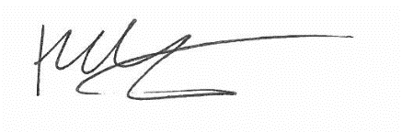

Ms Heidi Thurland
Headteacher
Medwards@middlewichhigh.cheshire.sch.uk
head@middlewichhigh.cheshire.sch.uk

