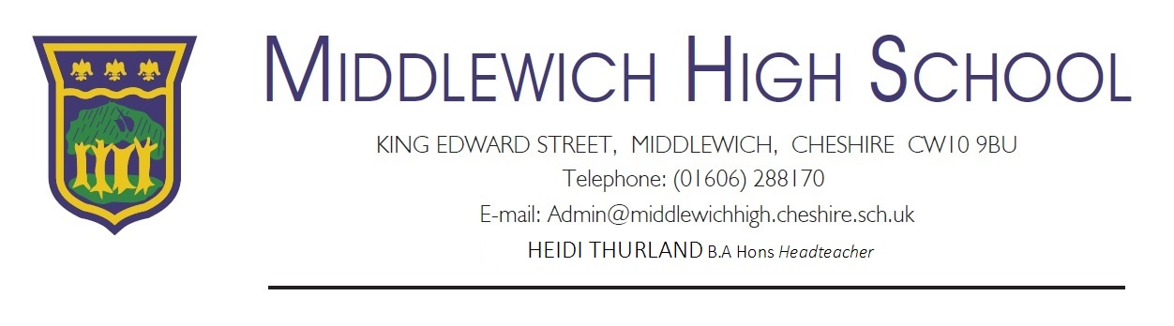
Dear Families,
Due to significantly reduced staffing capacity I have had to take the decision to partially close the school to specific year groups this week. On Thursday the 19th of March we will be closed to Yr9 students, on Friday 20th March we will be closed to Yr10 students. Yr9 students will return to us on Friday the 20th March, Yr10 students will return to us on Monday the 23rd March. This is not a decision we have taken lightly but it will enable me to continue to safeguard students effectively. My staff are currently focusing on covering absent colleagues so will not have the capacity to set work remotely, therefore during this period we ask that students access the following learning resources at home:
- Hegarty Maths https://hegartymaths.com/
- Seneca Learning https://www.senecalearning.com/
- GCSE Bitesize (Yr10) https://www.bbc.co.uk/bitesize
- Personal reading book
I will continue to keep you informed of any further requirement to work from home as a result of Government directives / staffing capacity.
If you have a safeguarding concern during this period please inform us by contacting reception or using the email contacts below:
Safeguarding Support: Should you need to access safeguarding support please use the following links/contacts:
Mr Wiseman swiseman@middlewichhigh.cheshire.sch.uk
Mrs Chisholm vchisholm@middlewichhigh.cheshire.sch.uk
Mrs Christmas vchristmas@middlewichhigh.cheshire.sch.uk
Mrs Robinson lrobinson@middlwichhigh.cheshire.sch.uk
Reception: 01606288170 (8am-4.30pm)
I would like to thank you for your continued understanding and support during this challenging time.
Regards

Heidi Thurland
Headteacher
Excellence in Learning – Achievement for All

